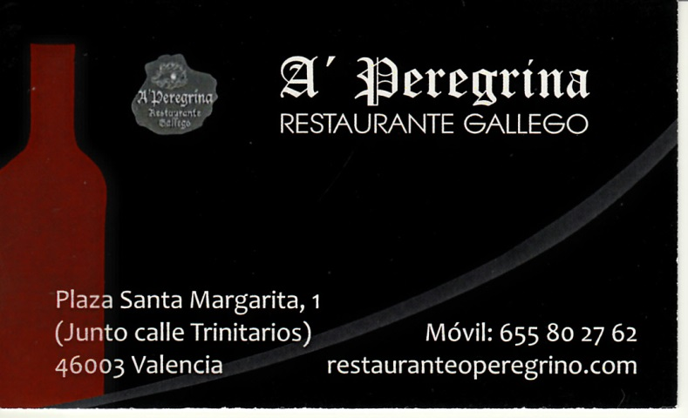
Santi60

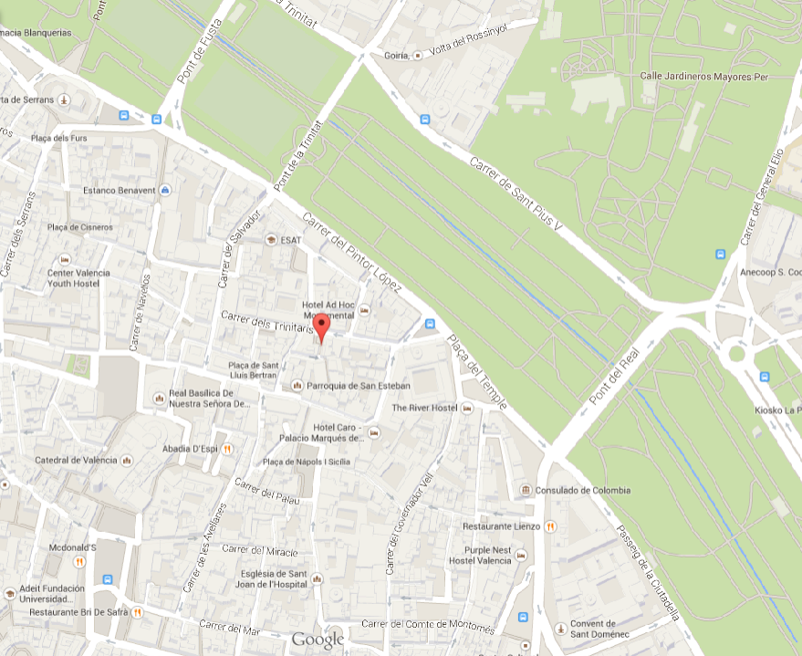

1st July 2014
10.00 h.
IFIC
Seminar room 1.1.1

Santiago Noguera, full professor at the Theoretical Physics Department of the University of Valencia, will accomplish his first 60th Birthday soon. In this event his former and present PhD students, and some of his friends, organize this celebration.
Programme
10.00 – Introduction
10.05 – Laudatio (Aurore Courtoy)
10.20 – “Symmetry breakings in a symmetric mind” (José Bernabéu)
10.40 – Former PhD students talk
11.00 – Coffee break
11.30 – “Minimal Flavour Violation in Two BEH Doublet Models”
(Francisco J. Botella)
11.50 – “25 years of a stimulating collaboration on various topics”
(Bertrand Desplanques)
12.10 – “Santi Pion and the Chiral Circle” (Vicente Vento)
12.30 – “The three-quark French connection” (Pedro González)
12.50 – “Between the mesons with Santiago” (Sergio Scopetta)
13.10 – Finale
14.30 – Gastronomic meeting. Restaurant A’Peregrina.
(Only for those who have registered)

